WatchList is a Web Application that allows a user to store, view, and alter a list of shows and their respective seasons, all of which is stored in a database.

The home page where you view all of the shows looks like this

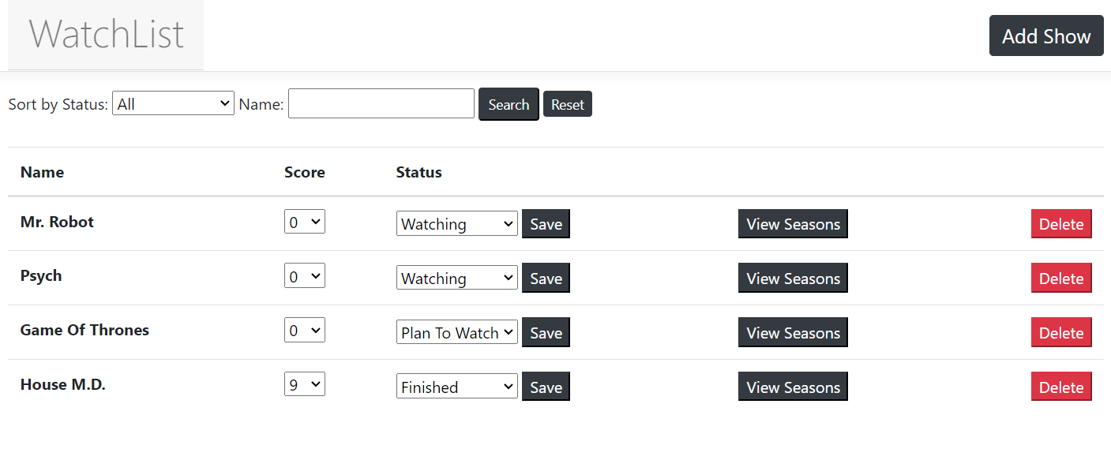

The shows by default are sorted by Status and Name, in that order. But you can specify the Status in the dropdown at the top to view only shows of that status, or you can enter some text in the ‘Name’ search-box to only view Shows that contain the input text somewhere within their name (this is not case sensitive). Or, of course, you can use both filtering methods at the same time.

Each Show has some options next to it, the ‘View Seasons’ option we’ll get to later. If you change the status and/or the score of a show, the ‘Save’ button will commit your changes to the database. Meanwhile the Delete button will remove that show from the database along with any seasons that are linked to that show.

The ‘Add Show’ Page consists of a simple form where you enter the basic information about the show you want to add to the database.

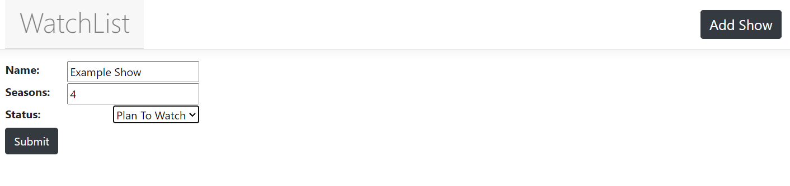

After Submitting the information to create a new show, the user will be directed to a page where they’ll enter the Episode they’ve watched, and the Total number of episodes for each season in the show. The application will automatically determine the Status of the season based on what they enter in these input boxes. If they enter zero episodes watched, it’ll set to ‘Plan To Watch’, if the episodes watched is equal to the episode total, it’ll set to ‘Finished’, otherwise it’ll set to ‘Watching’.

Since I set our example show above to status ‘Plan To Watch’, I will leave ‘Episodes Watched’ at zero for every season.

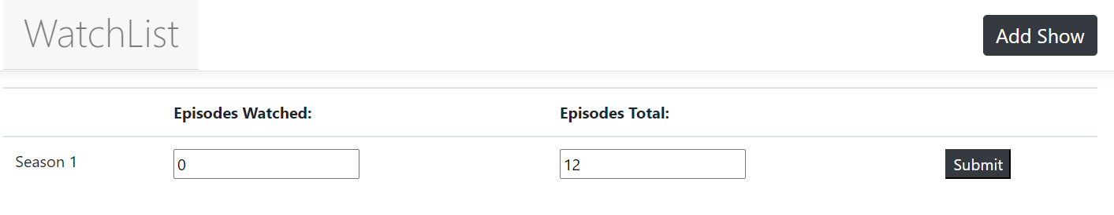

You can see our example show has been added to the home page.

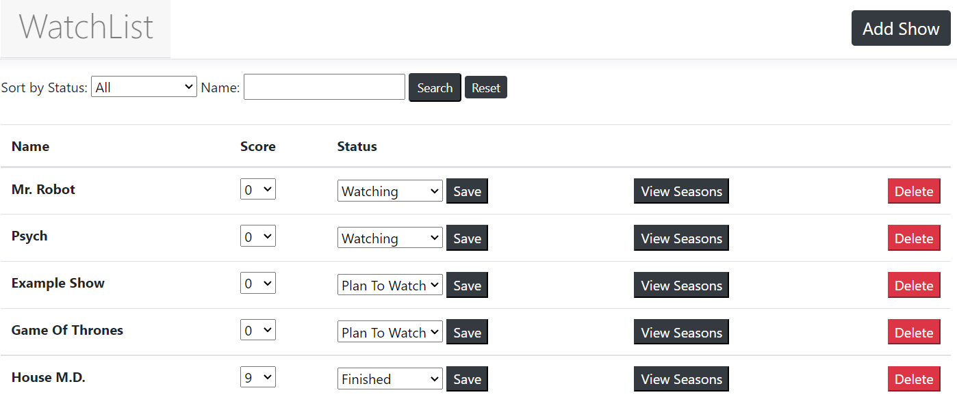

Now let’s take a look at the seasons for our Example show, you can see I’ve added some total episode amounts for all the seasons.

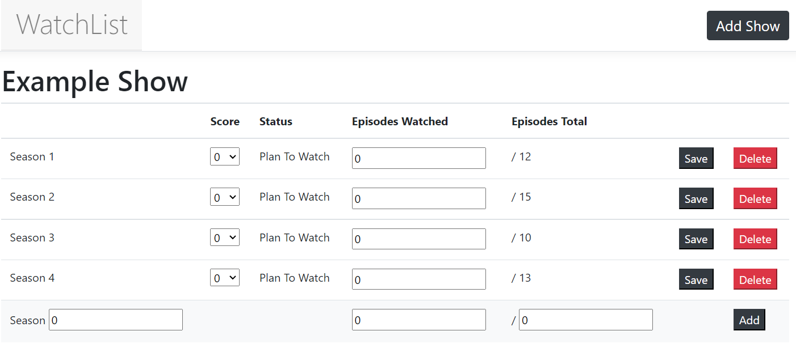

On this page there are two user inputs for every season in the table. You can change the score of each season, and you can change how many episodes you’ve watched, then of course you can commit these changes to the database via the ‘Save’ button. If you change the episodes watched, the status of the season will change accordingly. Changing the status of a season will also change the status of the associated show. If all season are set to ‘Plan To Watch’ or ‘Finished’ so too will the show be, otherwise the show will be set to ‘Watching’

At the bottom of the list is a form that can be used to Add a new season to the list. The numeric input next to ‘Season’ allows the user to specify the Order at which they’d like the season to be placed. If this input is set to a number that already exists in the show, all seasons currently at that Order or higher will be moved up by one to accommodate the new addition. Otherwise, if this input is set to a number that doesn’t already exist in the show, it will default to being one higher than the current highest.

Let’s add a new season and put it in the third spot.



You can see the seasons that used to be in the third and fourth spots are now in the fourth and fifth spots instead, and our new season has taken the third spot.

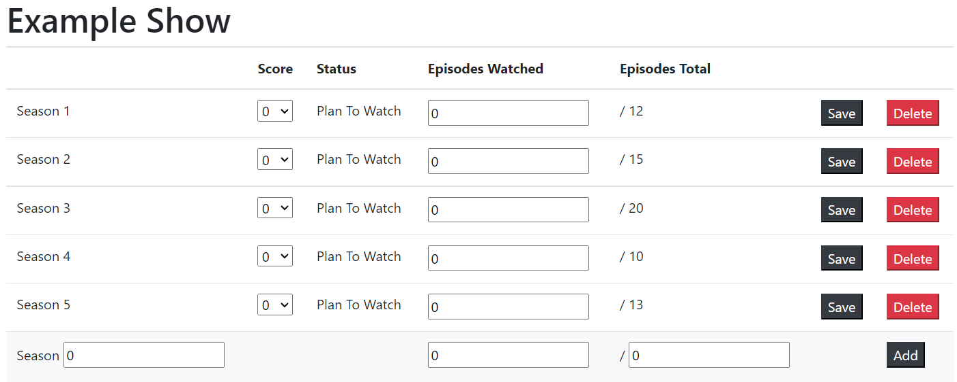

Now let’s go back to the homepage and manually set our show to ‘Finished’ status



You can see that all of the seasons have subsequently been set to ‘Finished’ as well, and the amounts for ‘Episodes Watched’ have been adjusted accordingly.

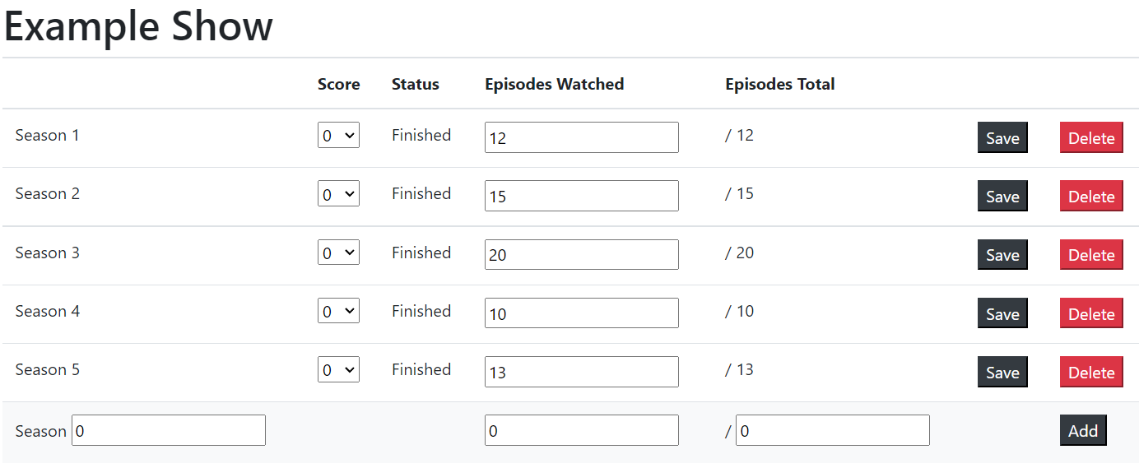

But now let’s decrease the episodes watched for one of the seasons to change its status to ‘watching’



You can see that the whole show gets its status adjusted to ‘watching’ as well, because not all of its seasons are finished anymore.